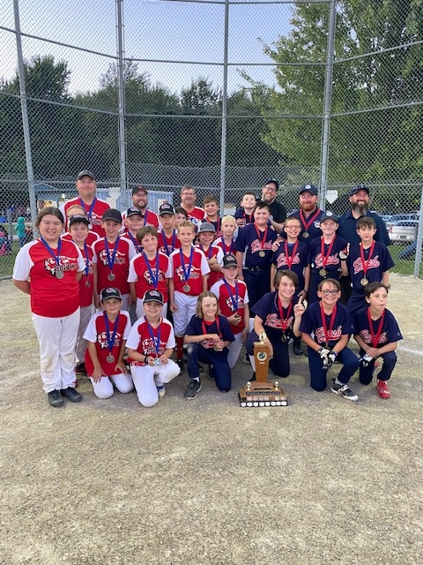

B Division Minto Crush Gold & Grand Valley Silver